#### Macintosh HD:Users:Owner:Desktop:Screen Shot 2017-02-11 at 6.15.17 PM.pngMacintosh HD:Users:Owner:Desktop:Screen Shot 2017-02-09 at 7.06.46 PM.pngMacintosh HD:Users:Owner:Desktop:Screen Shot 2017-02-11 at 6.15.34 PM.png

What’s Inside?

Expectations

Staff Position Descriptions

Story Typing Guidelines

Writing Leads

**Your Resources**

Your hands: take notes so that you report quotes accurately.

Your mouth: ask questions and identify yourself as a staff member of *The Shadow.*

Your feet: Go from place to place and talk to people. Legwork is essential!

Your ears: Listen for story ideas from conversations and announcements.

Your eyes: Look for new ideas!

**Time Management**

Acceptable Excuses: Medical excuses and/or funerals.

Unacceptable Excuses:

“I didn’t have time.”

“I don’t know those people.”

“I forgot.”

“I don’t have any story ideas.”

“

**Courtesy**

When criticized by anyone, whether it is faculty, staff, or students, reply that *The Shadow* welcomes criticism because we want to improve. However, be aware that not everyone is well versed in journalistic principles. Keep in mind that the individuals that make up the staff have different skill levels and talents. Everyone has something to contribute.

*The Shadow*

Reporter’s Guide

# **What is Expected of *THE SHADOW* staff members**

# Student Staff Position Descriptions

**Staff Descriptions**

Graphic Design/Technical Support Leader – Assists Miss Healey and students with GoogleSites, Microsoft Word, device troubleshooting, layout editing, pictures, graphics, and text. This individual must have proficient or advanced computer skills and must be able to work well with others, finding creative solutions to technical problems.

Junior Managing Editor - assists with overseeing the staff, reminding others about deadlines, assisting with meetings, assisting with editing instruction, working 1-to-1 with others to improve stories, other duties as assigned by Miss Healey.

Marketing/Advertising Manager – coordinates all sales, manages sales team, generates issue counts, coordinates promotional activities, other duties as assigned by Miss Healey.

These descriptions should help everyone understand the responsibilities of *The Shadow* staff members. However, there are several duties and responsibilities that may be unique to a particular issue, story, or situation that may not be listed here, so stay flexible.

Regardless of the position, everyone writes articles as a reporter. All staff members must contribute ideas and participate in other activities (running errands, taking pictures, delivering items, hanging posters, etc.)

Staff Advisor/Editor In Chief: Miss Healey

* Oversee entire production of paper.
* Instruct students on how to produce the paper as well as offer guidance.
* Maintain a master list of stories.
* Assist in paper layout.
* Read and “final edit” all stories.
* Promote a positive learning environment.

Type all stories in Microsoft Word. **Never type directly onto the page.** Always insert a text box and type inside it. Type all stories using 12 point Times New Roman font. Indent all paragraphs with one press of the tab key. Never indent with the space bar. Do not skip multiple spaces between paragraphs. Type only one space after a period at the end of a sentence. Save your story to the Y drive on your computer every time. I may request that you also put the file into your GoogleDrive, which is why you are creating a Google Account. This account can also be used for mail and the management of your own GoogleSite. When creating a name for your saved file, always put your first and last name, followed by the title of your story and RD (rough draft). Change it to FD (final draft) when finished. (Example: Joe Smith School Lunches RD)

**STORY TYPING GUIDELINES**

**“Consistency is key.”**

Save frequently while typing to preserve your work. If the Junior Managing Editor or I request a print copy of your story, then provide one. Do not forget to include Written by (your name) underneath your title. You will either edit your own articles, or we will work together in pairs or small groups to edit them. Although there will be many eyes looking over your article before it is published, it is ultimately your responsibility to ensure that there are no typographical errors or content errors in your writing.

Typing guidelines are important and must be followed. In order to format *The Shadow* correctly and efficiently, we must type out stories using these rules. If we all did our own blogs on different programs, layout editors would not be able to make all pages flow smoothly. It would look disjointed and unprofessional. *The Shadow* is your student newspaper and you should want to make a paper that not only sounds good, but also looks awesome.

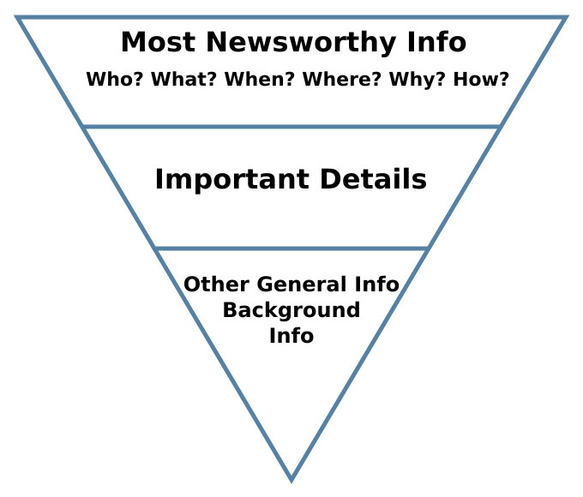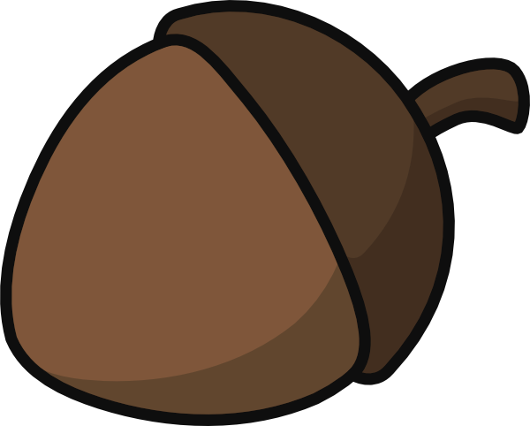

Writing Leads

So how does the story begin? The lead is the first paragraph in a news story. Do not confuse it with the headline. Leads present the most important facts and information. Think of it as a short summary. The rest of the paragraphs go into the details and specifics of the story. Complete leads will identify W’s and H’s like *who, what, when, where, why,* and *how* if that information is known. Leads order the information from most important to least important. Most leads are only one to two sentences that are clear and direct. Decide which W’s and H’s are important enough to go in the lead. Anything not important enough to be in the lead will go in the rest of the story. Many journalists use the “nut graph” seen below to organize their information. The stem represents the headline, top of the nut represents the lead, and the bottom of the nut represents the story. The goal is to make the squirrel (the reader) go for the nut!

Headline

Lead

Story