Name: ______________________________________ Period: _______ Newspaper Vocabulary
We will be using words from this list & learning them more in-depth throughout the semester.
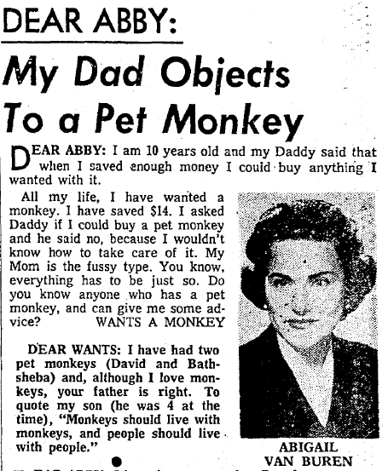
Keep this list for reference!
- Caption – a short description of a picture
- Column – regularly featured articles by the same writer (like Dear Abby)
- Conclusion – sums up important points in an article
- Consumer Review/Product Profile – evaluation or review of an advertised product
- Credit Line – text that identifies the photographer
- Editorial – short article expressing an opinion on something
- Entertainment Review – a review of music, movies, books, albums, etc.
- Future Lead – unlike the news lead, this is more creative and suspenseful
- Headline – Advertises the article, catches attention, draws reader in
- Inverted Pyramid – a way of organizing information that includes the most important details first, down to the least important details.
- Narrative lead – an article from the point of view of the person involved in the story
- Obituary – published notice of death, sometimes accompanied by a photograph.
- Satire – an article with a blend of criticism and tumor, used to ridicule people or groups with the object of inspiring change to be made
- Sidebar – additional information (like facts and statistics) located literally on the side of an article
- Sports Writing – the facts and analysis of the game

