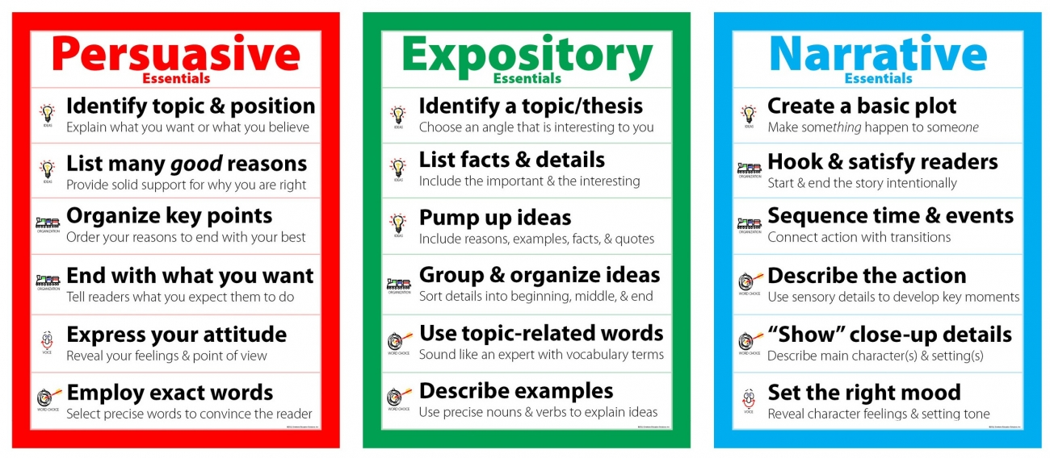
Name: _________________________________________ Period: _____ Types of Writing Brainstorm Sheet
Informative
Brainstorm Topics:
Brainstorm Topics:
Brainstorm Topics:

